Question : 1
Given a list of delivery timestamps as strings (e.g., ['2024-06-01 14:30', '2024-06-02 09:15', '2024-06-03 20:45']), use pandas and pd.to_datetime() to convert them into datetime objects and print the result :

import pandas as pd
timestamps = [
"2024-06-01 14:30",
"2024-06-02 09:15",
"2024-06-03 20:45"]
datetime_values = pd.to_datetime(timestamps)
print("Datetime values:")
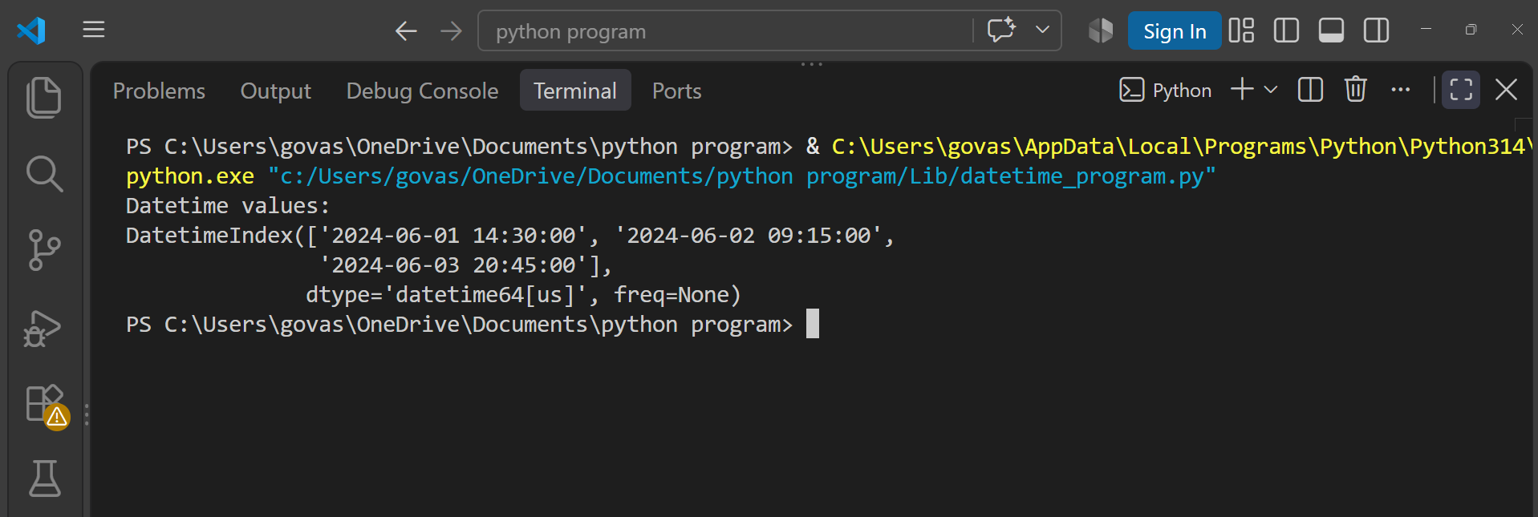
print(datetime_values)

Question : 2
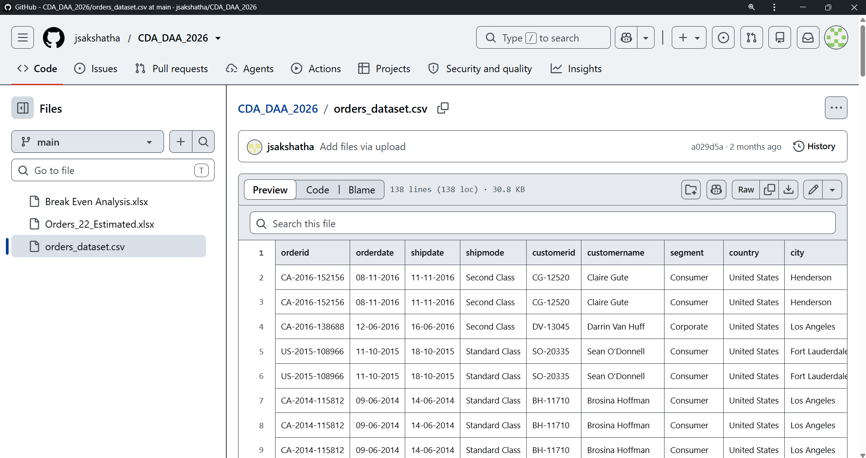
Load a CSV file containing order dates from a Flipkart-style order history (column: 'order_date', format: 'YYYY-MM-DD HH:MM:SS'). Extract the year, month, and weekday for each order and add them as new columns in the DataFrame :

import pandas as pd
df = pd.read_csv("Lib/orders_dataset.csv")
df["orderdate"] = pd.to_datetime(df["orderdate"], dayfirst=True)
df["year"] = df["orderdate"].dt.year
df["month"] = df["orderdate"].dt.month
df["weekday"] = df["orderdate"].dt.day_name()
print(df[["orderdate", "year", "month", "weekday"]].head())

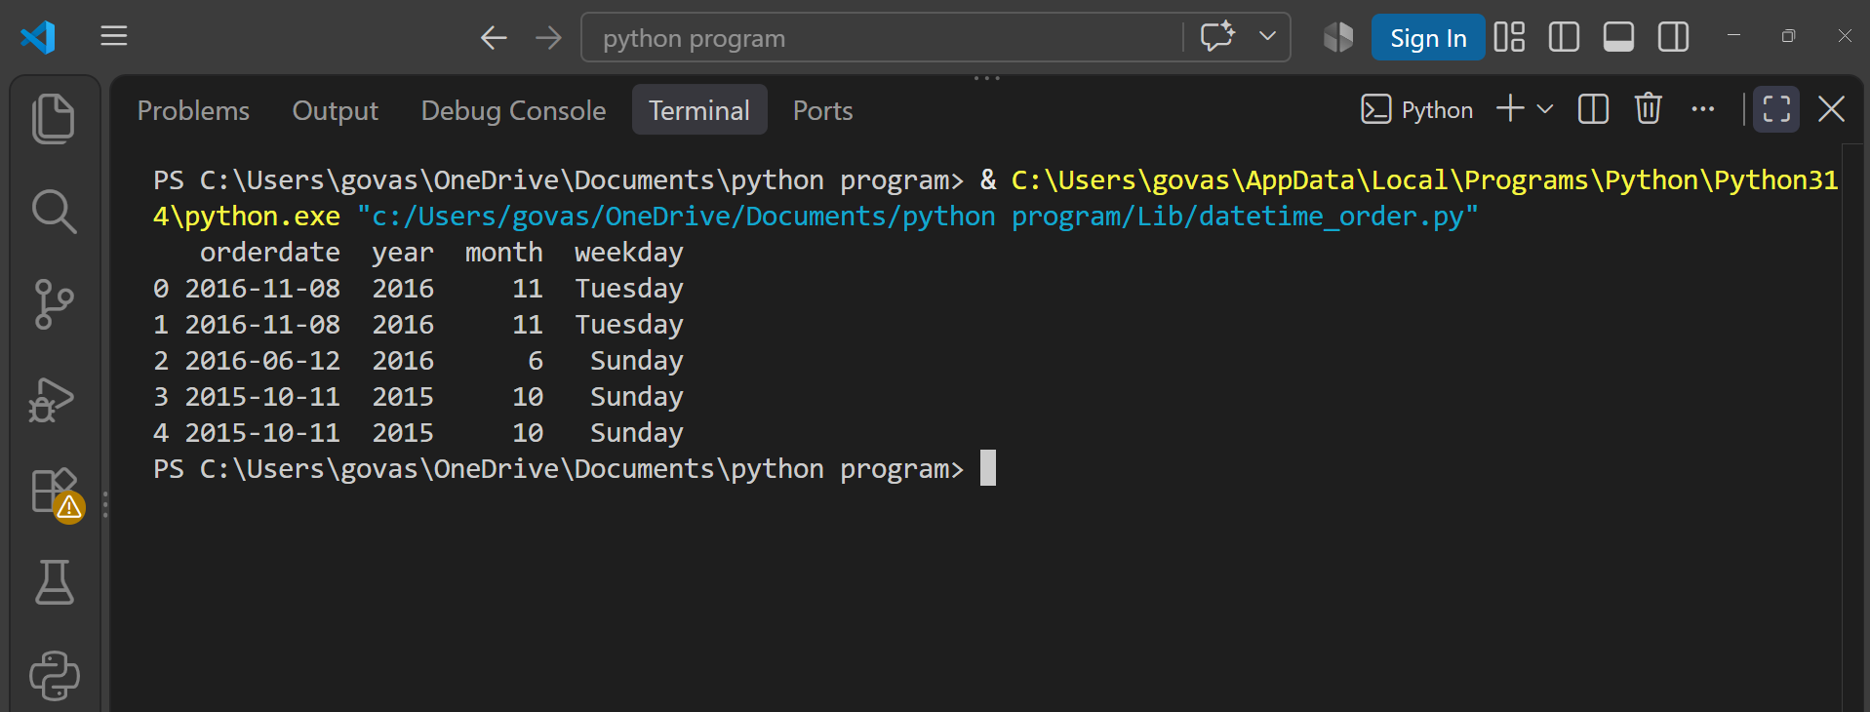
Question : 3
Set the 'order_date' column as the index of your DataFrame and use resampling to calculate the total number of orders placed each week.<br><br><em><strong>Hint:</strong> Use df.resample('W').size() after setting the datetime index : </em>

import pandas as pd
df = pd.read_csv("Lib/orders_dataset.csv")
df["orderdate"] = pd.to_datetime(df["orderdate"], dayfirst=True)
df = df.set_index("orderdate")
weekly_orders = df.resample("W").size()
print("Total Orders Per Week:")
print(weekly_orders)
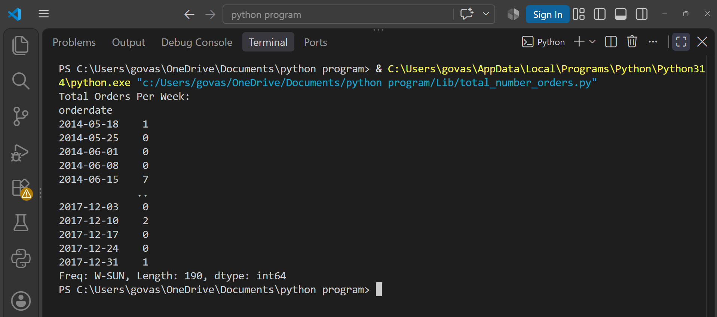
Question : 4
Suppose you have a DataFrame of Instagram posts with a 'posted_at' column in UTC. Convert these timestamps to 'Asia/Kolkata' timezone and display the first 5 converted times :
import pandas as pd
df = pd.DataFrame({
"posted_at": [
"2024-06-01 10:00:00",
"2024-06-02 12:30:00",
"2024-06-03 15:45:00",
"2024-06-04 18:00:00",
"2024-06-05 20:15:00"
]
})
df["posted_at"] = pd.to_datetime(df["posted_at"], utc=True)
df["posted_at_kolkata"] = df["posted_at"].dt.tz_convert("Asia/Kolkata")
print(df[["posted_at", "posted_at_kolkata"]].head())
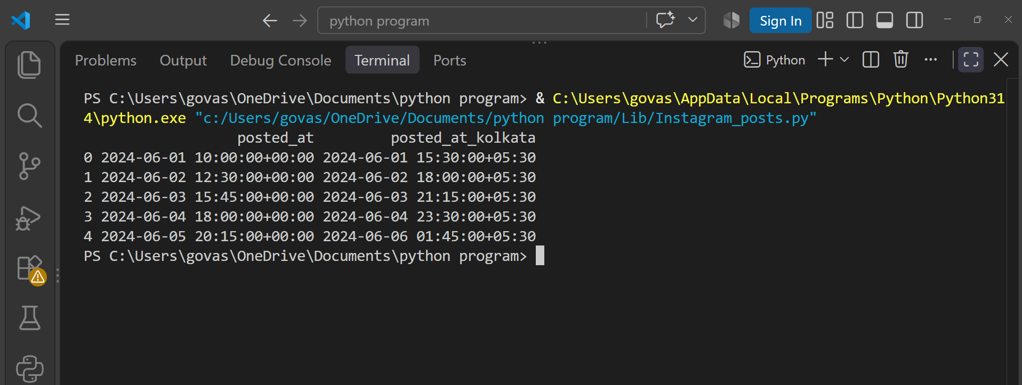

Question : 5
Create a new feature called 'is_weekend' in your DataFrame that marks True if an order was placed on Saturday or Sunday, and False otherwise.<br><br><em><strong>Constraint:</strong> Do not use any external libraries except pandas and numpy : </em>

import pandas as pd
df = pd.read_csv("Lib/orders_dataset.csv")
df["orderdate"] = pd.to_datetime(df["orderdate"], dayfirst=True)
df["is_weekend"] = df["orderdate"].dt.dayofweek >= 5
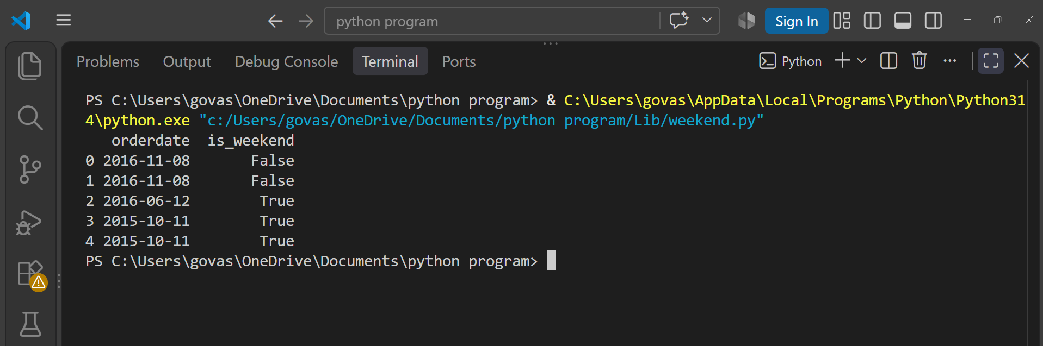
print(df[["orderdate", "is_weekend"]].head())

